|  |  |  |  |  |
| --- | --- | --- | --- | --- |
|  | r16 | r17 | r18 | r19 |
| Line 1 | 04 | - | - | - |
| Line 2 | 04 | 06 | - | - |
| Line 3 | 04 | 06 | 01 | - |
| Line 4 | 04 | 06 | 01 | F8 |
| Line 5 | A | - | - | - |
| Line 6 | 9 | - | - | - |
| Line 7 | 101 | - | - | - |

Logbook

Task 0  
Examine the above program and complete the following table, showing the contents of each register after each line of the above program, is executed. Upload the grid and program flow chart to your logbook. This is predicted

* FLOWCHART

ldi   r16,$04    ;Line 1 - Put 04 HEX into register r16

ldi   r17,$06    ;Line 2 - Put 06 HEX into register r17

ldi   r18,$01    ;Line 3 - Put 01 HEX into register r18

ldi   r19,$F8    ;Line 4 - Put F8 HEX into register r19

add   r16,r17    ;Line 5 - Add contents of r16 to r17 and put the total in r16

sub   r16,r18    ;Line 6 - Subtract the contents of r18 from the total in r16 and put the answer in r16

add   r16,r19    ;Line 7 - Add the contents of r16 to r19 and put the total in r16   
  
end:  rjmp  end        ;loop forever

## Task 1

Single step (F10) through the program and complete the following table, showing the contents of each register after each line of the above program, is executed. Are the contents of the registers the same as you predicted in the table above? If not why not? Upload the grid and program flow chart to your logbook. This is when executed the program.

|  |  |  |  |  |
| --- | --- | --- | --- | --- |
|  | r16 | r17 | r18 | r19 |
| Line 1 | 04 | - | - | - |
| Line 2 | 04 | 06 | - | - |
| Line 3 | 04 | 06 | 01 | - |
| Line 4 | 04 | 06 | 01 | F8 |
| Line 5 | A | 06 | 01 | F8 |
| Line 6 | 09 | 06 | 01 | F8 |
| Line 7 | 01 | 06 | 01 | F8 |

* FLOWCHART

## 

## Task 2

The following  program should produce the answer to **3a + 2b - c** where **a=4**, **b=3**, **c=19**. Calculate what the answer should be. **Answer -1**

## Task 3

Assemble the above program and correct the syntax errors. Explain the relationship of the answer produced by the simulator to the answer you calculated. Upload the corrected program and flow chart to your logbook.

Program to calculate 3a + 2b - c

.equ a =4

.equ b =3

.equ c =19

ldi r16,a

ldi r17,b

ldi r18,c

;use register r20 to calculate 3a

ldi r20,$0

add r20,r16

add r20,r16

add r20,r16

;use register r21 to calculate 2b

add r21,r17

add r21,r17

;add 3a to 2b and put the result in r20

add r21,r20

ldi r20, $0

mov r20, r21

ldi r21, $0

;put c into r22 then take it from the total in r20

ldi r22,c

sub r20,r22

end: rjmp end ;loop forever **ANSWER: -1 FF**

* FLOWCHART

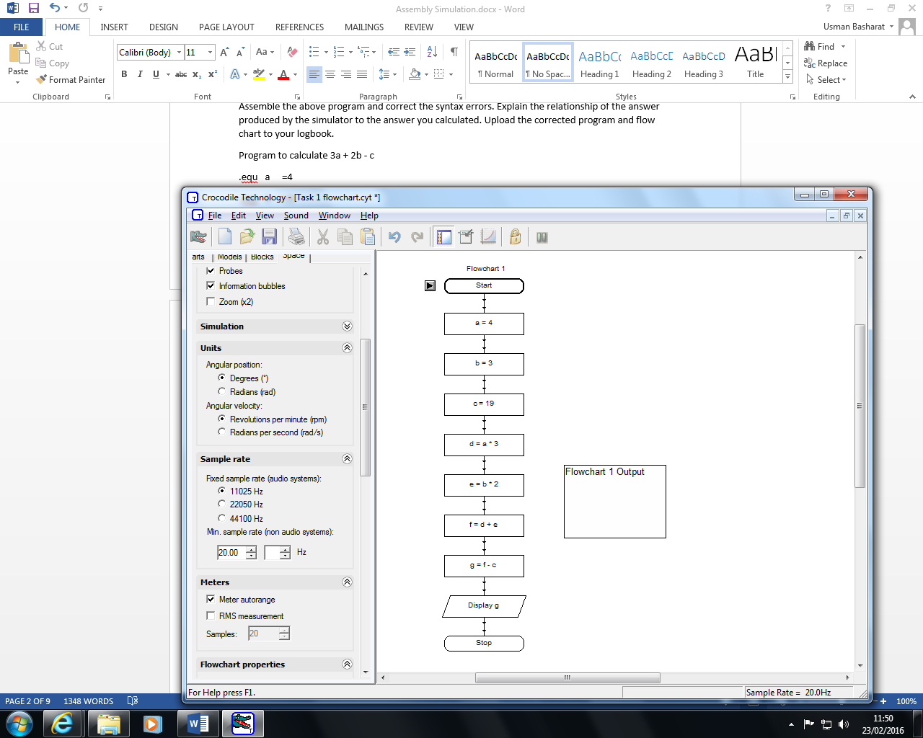

## Task 4

Assemble and single step the above program. Identify which flags are set in the status register and explain why the instruction / data caused the each of the flags to be set. Indicate which instructions do not effect the flags.  Upload the completed table to your logbook. To understand the process that is occurring, you need to notate the values of r16 and r17 in binary.

|  |  |  |  |  |  |  |  |  |  |  |  |  |
| --- | --- | --- | --- | --- | --- | --- | --- | --- | --- | --- | --- | --- |
| ;flag test program | | r16 | r17 | I | T | H | S | V | N | Z | C | Explanation |
| ldi | r16,$80 | 10000000 | - | - | - | - | - | - | - | - | - | Instruction does not effect flags |
| ldi | r17,$80 | 10000000 | 10000000 | - | - | - | - | - | - | - | - | Instruction does not effect flags |
| add | r16,r17 | 00000000 | 10000000 | 0 | 0 | 0 | 1 | 1 | 0 | 1 | 1 | Status: - Sign Flag, Twos Complement Overflow Flag, Zero Flag and Carry Flag. These flags are used to add those two numbers together. |
|  |  |  |  |  |  |  |  |  |  |  |  |  |
| Ldi | r16,$78 | 0111 1000 78 | 1000 0000 80 | 0 | 0 | 0 | 1 | 1 | 0 | 1 | 1 | Instruction does not effect flags |
| Ldi | r17,$63 | 0111 1000 78 | 0110 0011 63 | 0 | 0 | 0 | 1 | 1 | 0 | 1 | 1 | Instruction does not effect flags |
| Add | r16,r17 | 1101 1011 DB | 0110 0011 63 | 0 | 0 | 0 | 0 | 1 | 1 | 0 | 0 | Status: - Twos Complement Overflow Flag and Negative Flag |
|  |  |  |  |  |  |  |  |  |  |  |  |  |
| Ldi | r16,$FC | 1111 1100 FC | 0110 0011  63 | 0 | 0 | 0 | 0 | 1 | 1 | 0 | 0 | Instruction does not effect flags. Status the same. |
| Ldi | r17,$F9 | 1111 1100 FC | 1111 1001 F9 | 0 | 0 | 0 | 0 | 1 | 1 | 0 | 0 | Instruction does not effect flags. Status the same. |
| Add | r16,r17 | 1111 0101 F5 | 1111 1001 F9 | 0 | 0 | 1 | 1 | 0 | 1 | 0 | 1­ | Status: - Half Carry Flag, Sign Flag, Negative Flag and Carry Flag. |
|  |  |  |  |  |  |  |  |  |  |  |  |  |
| Ldi | r16,252 | 1111 1100 FC | 1111 1001 F9 | 0 | 0 | 1 | 1 | 0 | 1 | 0 | 1­ | Instruction does not effect flags. Status the same. |
| Ldi | r17,249 | 1111 1100 FC | 1111 1001 F9 | 0 | 0 | 1 | 1 | 0 | 1 | 0 | 1­ | Instruction does not effect flags. Status the same. |
| Add | r16,r17 | 1111 0101 F5 | 1111 1001 F9 | 0 | 0 | 1 | 1 | 0 | 1 | 0 | 1­ | Status the same. |

Last two the same. 252 is FC in Hexadecimal and 249 is F9 in Hexadecimal. However, the flags, for the last code, has the same flags for all three lines.

## Task 5

Perform the following bitwise operations and upload the table to your logbook. To understand the process that is occurring, you need to notate the operand values in binary.

|  |  |  |  |
| --- | --- | --- | --- |
| Operator | Operand 1 | Operand 2 | Answer |
| NOT | $A5 |  | $90 (01011010) |
| AND | $A5 165 | $0F | $5 (00000101) |
| OR | $A5 165 | $0F | $175(1010 1111) |
| XOR | $A5 165 | $0F | $170 (10101010) |

Go over this again!

For an eight bit register

|  |  |  |  |  |  |  |  |
| --- | --- | --- | --- | --- | --- | --- | --- |
| bit 7 | bit 6 | bit 5 | bit 4 | bit 3 | bit 2 | bit 1 | bit 0 |

Complete the following table, notate the operand values in binary and hexadecimal

|  |  |  |  |  |
| --- | --- | --- | --- | --- |
|  | Operand 1 | Operator | Operand 2 | Answer |
| Flip bits 4 and 5 | $A5 (1010 0101) | AND | 1000 0101 | $95 (1001 0101) |
| Extract bits 1 and 5 | $A5 (1010 0101) | NOT | - | 0101 1010 |
| Set bits 4 and 6 to 1 | $A5 (1010 0101) | XOR | 65 | 228 |
|  | $A5 (1010 0101) | OR | $47 (0100 0111) | $E7(1110 0111) |

Do flowchart

Task 6

;bit shifting and rolling

.equ a =$FF

ldi r16,f

ldi r17,f

ldi r18,f

ldi r19,f

lsl r16

lsl r16

lsl r16

lsl r16

com r16

andi r16,$c0

lsr r17

lsr r17

andi r17,$30

lsl r18

lsl r18

andi r18,$c

lsr r19

lsr r19

lsr r19

lsr r19

com r19

andi r19,$3

or r16,r17

or r16,r18

or r16,r19

end: rjmp end

**Task 7**

ldi r16,9

|  |  |
| --- | --- |
| Execution Order | R16 |
| 1 | 09 |
| 2, 3, 4 | 08, 07, 06 |
| 5, 6, 7 | 05, 04, 03 |
| 8, 9, 10 | 02, 01, 00 |

loop: dec r16

dec r16

brne loop

end: rjmp end

ldi r16,0

|  |  |
| --- | --- |
| Execution Order | R16 |
| 1 | 01 |

loop: inc r16

cpi r16,4

breq loop Spins

end: rjmp end

|  |  |
| --- | --- |
| Execution Order | R16 |
| 1, 2 | 01, 02 |
| 3 | 03 |
| 4 | 04 |
| 5 | 05 |

ldi r16,1

loop: inc r16

cpi r16,5

brne loop

|  |  |
| --- | --- |
| Execution Order | R16 |
| 1 | 03 |
| 2 | 04 |
| 3 | 05 |
| 4 | 06 |

ldi r16,3

loop: inc r16

cpi r16,6

brne loop

This one only goes up to 6 and stops. Once it reaches 6, the loop stops. However, the difference between this one and the above is this one starts at 3 and goes up. However, the top one goes from one.

end: rjmp end

|  |  |
| --- | --- |
| Execution Order | R16 |
| 1 | 01 |
| 2 | 02 |
| 3 | 03 |
| 4 | 04 |

ldi r16,1

loop: inc r16

cpi r16,3

breq next

next: rjmp loop This one goes in steps of adding each one again and again. This is the same as the first one instead it goes forward, not back. The first one and the last one does not stop. This is because it keeps adding one again and again to each other. It is like a forever loop.

end: rjmp end

**Task 8**

program to calculate 7+6+5+4+3+2+1 using a loop

ldi r16,0

ldi r17,7

loop: add r16,r17

dec r17

brne loop

end: rjmp end ;loop forever

answer 1C



;program to calculate 7+5+3+1 using a loop

ldi r16,1

ldi r17,5

loop: add r16,r17

dec r17

brne loop

end: rjmp end ;loop forever

answer 10 in hex



**Task 9**

;Nested loop example

ldi r16,$28 ;Initialise counter

ldi r24,$5 ;Initialise 2nd loop counter

loop2: ldi r25,$20 ;Initialise 1st loop counter

loop1: inc r16 ;Increment counter

dec r25 ;Decrement the 1st loop counter

brne loop1 ;and continue to decrement until 1st loop counter = 0

dec r24 ;Decrement the 2nd loop counter

brne loop2 ;If the 2nd loop counter is not equal to zero repeat the 1st loop, else continue

end: rjmp end ;loop forever

answer C8

**Task 10 Reflection**

It was all good. I felt that this was an exercise teaches how to use AVR programming language. I felt that Task 6 was the toughest out of all. I did the rest of them easily and understood this good. However, Task 6, I had to go over each of the notes to understand what is going on. After this, I understood that there was an not under bit 2, 3, 4 and 5. Once I did this, the tutor checked the code and got told that this was correct. I moved on to the other tasks and completed teach of them very quickly.